TASK 6 – EVALUATE THE COST OF SYSTEM CALLS
Course Code: CSA04
Course Name: Operating Systems
Course Outcome: CO1
Marks: 4
Full Question
Evaluate how the number of system calls affects performance.
Discuss:
- Why each system call costs much more than an ordinary function call.
- How the buffer size changes the number of read() and write() calls when the database copies a file.
- How library buffering (fread, fwrite) reduces the number of system calls.
- The best buffer size for the hospital’s backup program, using measurements.
Complete the given C program using read() and write() system calls.
AIM
To evaluate the cost of system calls by copying a file using different buffer sizes and comparing the number of read() calls.
ANSWER
1. Introduction
A system call is a mechanism through which a user program requests a service from the operating system kernel.
Examples of system calls include read(), write(), open(), close(), fork() and exec().
System calls require switching from user mode to kernel mode. This process involves additional overhead compared to ordinary function calls.
In a hospital, large patient records and MRI image files must be copied and backed up efficiently. The number of system calls directly affects the performance of these operations.
2. Why System Calls Are Expensive
An ordinary function call executes within the same process and generally does not require a mode switch.
A system call involves the following steps:
- The user program prepares the system call parameters.
- A trap or system-call instruction is executed.
- The CPU switches from user mode to kernel mode.
- The kernel validates the parameters.
- The kernel performs the requested operation.
- The result is returned to the user program.
- The CPU switches back to user mode.
These operations introduce overhead. Therefore, reducing unnecessary system calls improves performance.
3. Effect of Buffer Size
Buffering allows multiple bytes to be transferred during one system call.
For a 10,000-byte file:
Buffer Size | Number of Data Reads | EOF Read | Total read() Calls
1 byte | 10,000 | 1 | 10,001
512 bytes | 20 | 1 | 21
4096 bytes | 3 | 1 | 4
A larger buffer reduces the number of system calls.
A buffer of 4096 bytes is more efficient than a buffer of 1 byte because it transfers more data in a single operation.
4. Library Buffering
C library functions such as fread() and fwrite() use internal buffers.
Instead of performing a system call for every byte, the library collects data in a buffer and transfers it in larger blocks.
Advantages:
- Reduces system-call overhead.
- Improves file-copy performance.
- Reduces the number of kernel transitions.
The library requires additional memory for its buffer.
5. C Program – Complete Code
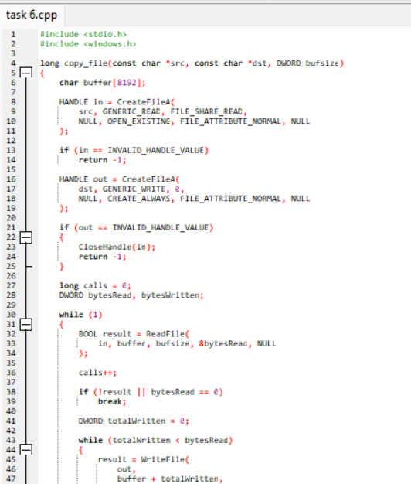
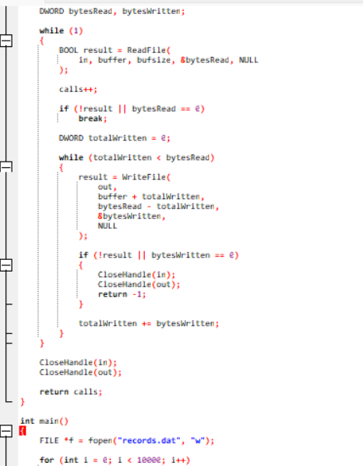
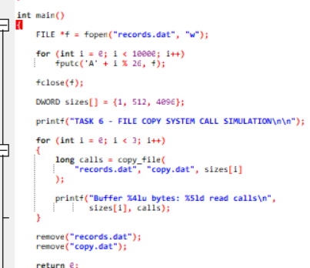

6. Expected Output
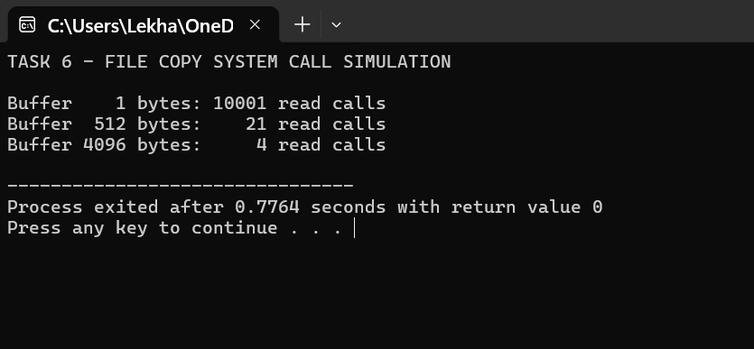

7. Explanation of Output
When the buffer size is 1 byte, the program requires 10,000 reads to transfer the file and one additional read to detect the end of the file.
When the buffer size is 512 bytes, the file requires 20 data reads and one EOF read.
When the buffer size is 4096 bytes, the file requires only three data reads and one EOF read.
Therefore, increasing the buffer size significantly reduces the number of system calls.
8. strace Comparison
Execute the program in Linux using:
gcc task6.c -o task6
./task6
strace -c ./task6
The strace -c command displays the system-call statistics.
The actual strace count may include additional calls used by program startup, file creation and cleanup. The program's printed count specifically counts the read() calls made inside copy_file().
9. Alternative Concept – Memory-Mapped Files
If the backup program uses mmap() instead of read() and write(), the file can be mapped into the process's virtual address space.
Advantages:
- Fewer explicit system calls.
- Convenient access to file data.
- May reduce copying between kernel and user space.
- Useful for large files.
Disadvantages:
- Mapping very large files may require substantial virtual address space.
- Page faults still occur.
- Memory-mapped files require careful handling.
- It is not automatically faster for every workload.
10. Recommended Buffer Size
For the hospital backup program, a buffer size of 4096 bytes is more efficient than 1 byte or 512 bytes in this experiment.
For actual hospital backups, a larger buffer such as 64 KB or 1 MB may also be tested. The best size should be selected based on measured throughput, memory use and workload.
CONCLUSION
The experiment demonstrates that buffer size significantly affects system-call overhead. Larger buffers reduce the number of read() calls and improve file-copy efficiency. A buffered approach is recommended for hospital backup operations because it reduces unnecessary kernel transitions and improves performance.
Screenshot Instructions
Paste these screenshots in this order:
- Screenshot of the complete C program.
- Screenshot of the compilation command.
- Screenshot of the expected program output.
- Screenshot of strace -c results.

